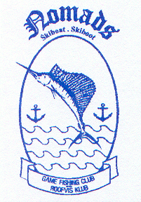 | NOMADS | GAME FISHING CLUB  ROOFVISKLUB
 | Office:  CR Swart Park  Rynfield – 1501  email: nomadsfishing@gmail.com  Website: www.nomadsfishing.co.za |  | Postal:  P.O Box 13899  Northmead  1511

Interclub Nomination

Angler’s Name |  | Shirt Size

Name of Interclub

Date of Interclub

Angler’s Contact Details
Postal address
Physical address
Tel (work/home)
Tel (fax)
Tel (mobile)
email

Have you taken part in any Nomads sanctioned competition?
YES |  | NO

Have you taken part in the Southern Gauteng Development course?
YES |  | NO

Do you have the basic equipment ie. suitable rods & reels?
YES |  | NO |  | Assistance Required

Do you understand the basic IGFA rules?
YES |  | NO |  | Assistance Required

Please note:
If any assistance is required it is in the angler’s best interests to request it.
The request for assistance will in no way jeopardise the selection process and in turn will act in the angler’s favour.

Signed: |  | Date:

